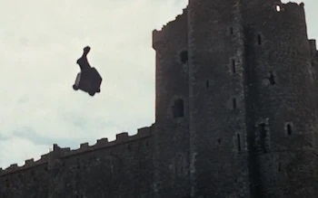
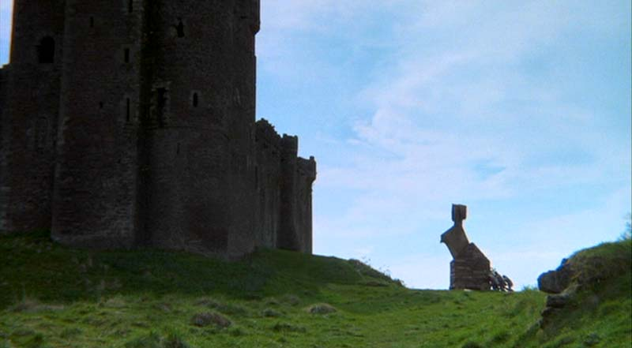
NOTE
NOTE
Happy birthday!
I got you a rabbit statue.

Its not loaded with soldiers,
I promise.
My general failed to explain that step.
On second thought I should load it.

Right then,
please return to sender,
that I might do better next year.
Happy Birthday Dustin!

From Nathan

